JOIN US ON GOWER
Not only is the Gower Peninsula an Area of Outstanding Natural Beauty (the first in the UK designated as such) but it ranks among the richest anywhere in ancient sites and places regarded as Sacred. This magical peninsula, lingering 18 miles out into the Irish Sea, with the Atlantic beyond, steeped in Celtic mythology and possessing innumerable Megalithic sites in areas of special energy. For millennia, these sites have been the destinations of pilgrimage for people to experience powerful resonance in their bodies, minds and spirits. Join us in following the paths of our ancient ancestors and take time to experience the energies. Reconnect with both our natural senses of the Earth and our ancient heritage.

We offer several workshops which involve visits to such sites on Gower with options to explore different areas of interest::
- Our Ancient Past: Archaeology and Historical perspective
- Earth Energies: Ways to connect to the Energies of these sites through one’s senses, to benefit health and well-being. Experiential workshop to make full use of the special qualities of these sites: August 22nd - 24th and Sept. 6th – 8th
- Drawing on Natural Energy: Ways to use drawing and painting as tools of awareness, to explore the connections to Energies we feel in these areas and to express the personal experience of that connection. August 25th 26th Sept. 9th-10th (no experience in art necessary)

A few of the sites we visit:
- King Arthur’s stone – megalithic monument – astronomically aligned
- Burry Holmes –tidal island with occupation from Bronze and Iron ages to pre-Norman with ruins of a Celtic chapel/hermitage
- Parc Cwm – Bronze age communal burial site
- Oxwich church – site of original Celtic cell
- Llangennith church – site of St. Cenydd’s priory

ANCIENT POWER SITES

WORKSHOPS ON THE GOWER PENINSULA

SOUTH – WEST WALES – UK

Re-connecting with our ancient heritage

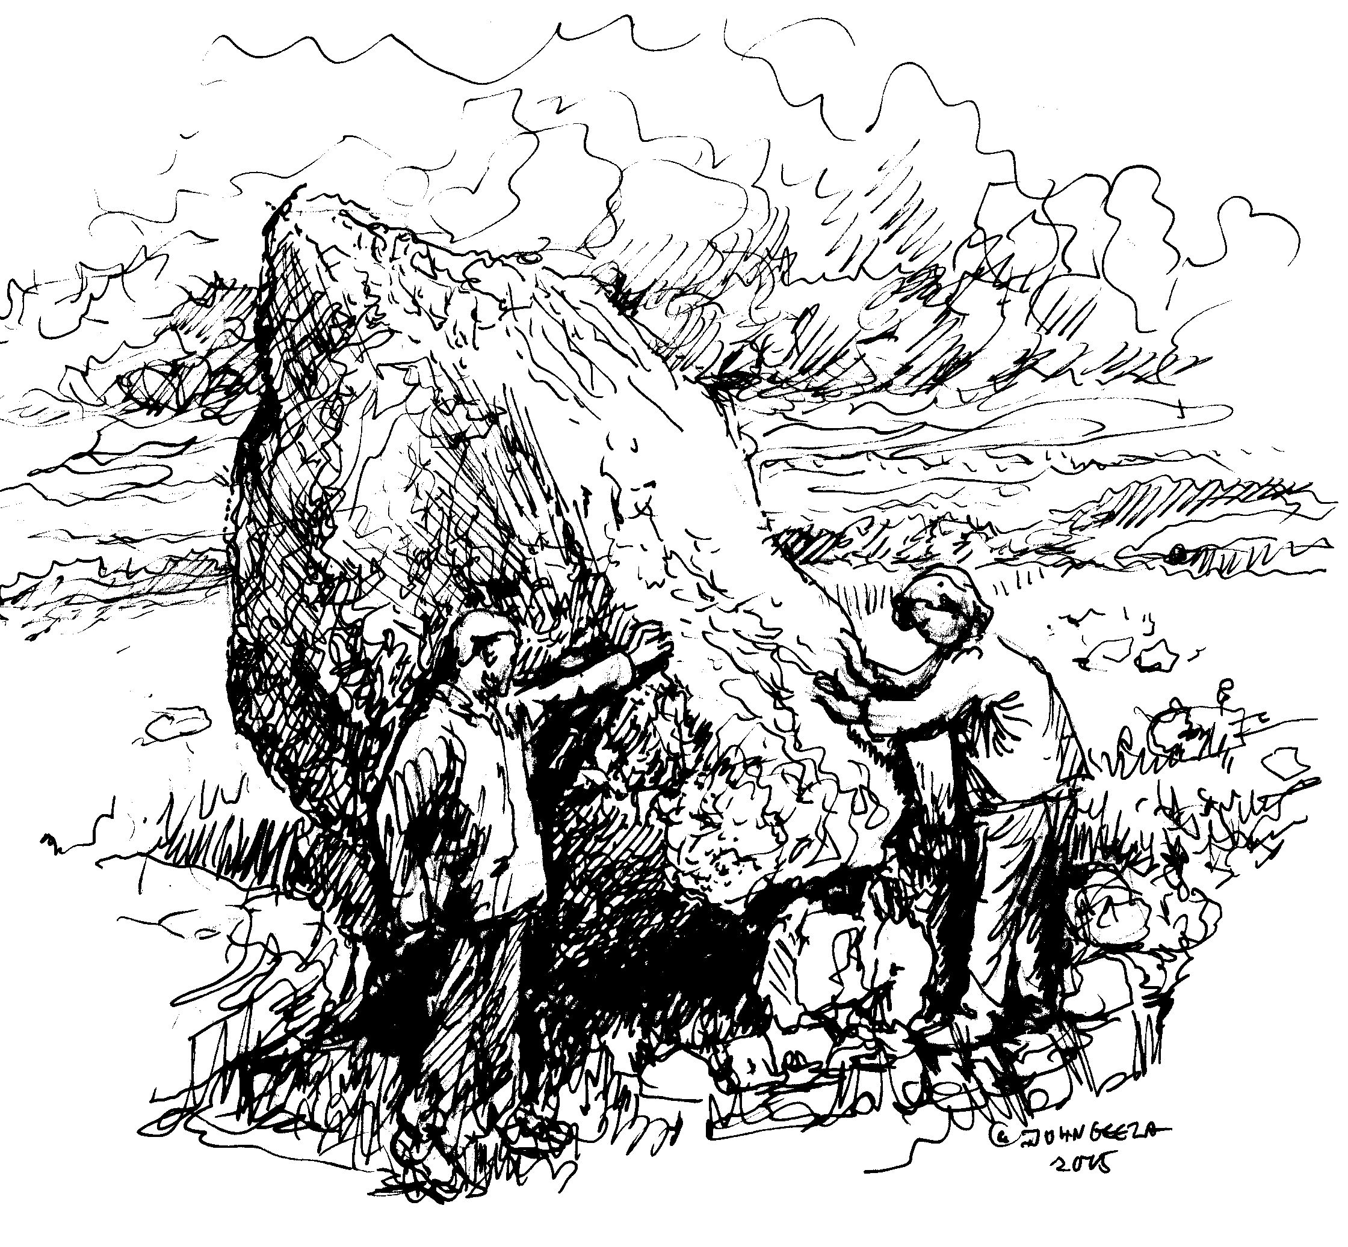

Workshops on the Gower Peninsula South Wales, focusing on earth energies, the spirituality of ancient and Celtic sacred sites, and human history.
The workshops and tours will emphasize "connecting" with not only the natural energies of these sites but also enjoying the countryside and hospitality.

http://www.ambilacuk.com/celticpowersites

.

OUR GUIDES

Our main guide to the region and its archaeological and historical significance will be Howard Middleton-Jones, an astronomical archaeologist, educator and author of a definitive guide book to Gower’s ancient heritage, who has known, lived and worked as a conservation Warden in Gower and has written on the ancient and sacred sites both here and in Egypt. His books on the significance of the substructures under the Great Pyramids have been in Amazon’s best sellers list. He lives in Mumbles, Swansea.

The co-leaders will be Dr Julianna Switaj and John Geeza, Both are educators, counsellors and research practitioners in mind-body-spirit medicine. Julianna brings special qualifications for these workshops: she is Welsh by birth, and comes from a long line of traditional healers. John’s ancestors from Central Asia, were forbearers of the Celts, and John has studied with North American shamans. His drawings and paintings are in private collections and galleries in the UK and Canada, and he is in demand as a teacher of people who believe they are not able to draw. Julianna and John now live in Canada, but regularly re-visit Wales to restore their souls and reconnect with the soil. They have 30 years combined experience in teaching groups and individuals ways to reconnect with the powers of Nature and to access their own hearts’ wisdom for problem solving and health promotion.

OUR BASE FOR EXPLORATION

The workshops and accommodation will be centred within the grounds of the Seren retreat, Fairwood Common, Gower. Set in 23 acres of ancient woodland and meadows, including six acres of ancient oak forest, the grounds are completely private. The main house has a spacious living – meeting room, with panoramic views of the surrounding countryside, a patio, formal garden and children’s play area. The centre specialises in vegetarian food and offers healthy dietary options. The Welsh Tourist board has given Seren Retreat a three star Bed and Breakfast rating. For further information please link to http://www.serenretreat.com

Accommodation is at the Seren retreat, where evening meals may be booked as an optional extra. Two whole days will be spent on the magnificent Gower Peninsula visiting several of the unique ancient sites and taking time to soak in the
abundant energies. There will also be additional and optional workshops to extend interest in art associated with these sites.

WHAT THE PROGRAMS INCLUDE
- Excellent three star B&B accommodation in idyllic surroundings.
- Full instruction and guidance by qualified and experienced practitioners and transport to and from all sites.
- Free CD of the site locations on Gower.
There is also a pick up service from the centre of Swansea to the centre on the Friday – details on booking.

NOT INCLUDED: Personal/luggage insurance and personal expenses. Pub lunches while on site visits. However, packed lunches are included if required.) Evening meals are an optional extra giving the flexibility to visit a few of the local dining places.

THE COSTS
Total cost of weekend workshop £230. Deposit of £50 required if booking more than 28 days prior to course, otherwise full amount required. See booking form for full details.

For additional information and details on our separate archaeological trails please refer to our website –
http://www.ambilacuk.com/celticpowersites
http://www.ambilacuk.com/flint2fortress

howardmj@yahoo.com
Telephone (UK) 01792 548836

Or Julianna and John: jswitaj@inetsonic.com

ANCIENT POWER SITES BOOKING FORM
A deposit is required of £50 or whole amount (£230) if booking within 28 days of tour date. . Paypal also accepted – payable to howardmj@yahoo.com see website
Preferred date of tour……………………………………………………………………
NAME………………………………………………………………………………………..
ADDRESS……………………………………………………………………………………
……………………………………………………………………………….
………………………………………………………………………………..
Tel. No……………………………………………………………………….
E-mail………………………………………………………………………...
Dietary preferences (Vegetarian etc)…………………………………..
All cheques etc payable to Ambilac-UK - Please send booking with payments to:
Ancient Power sites; 3 William Street, Mumbles, Swansea SA3 4LJ UK
E-mail howardmj@yahoo.com Tel: +44 (0) 1792 548846
http://www.ambilacuk.com/celticpowersites
We reserve the right to cancel bookings in the event of unforeseen circumstances. However, under these rare conditions all payments will be refunded in full

ANCIENT POWER SITES BOOKING FORM
A deposit is required of £50 or whole amount (£230) if booking within 28 days of tour date. . Paypal also accepted – payable to howardmj@yahoo.com see website
Preferred date of tour……………………………………………………………………
NAME………………………………………………………………………………………..
ADDRESS……………………………………………………………………………………
……………………………………………………………………………….
………………………………………………………………………………..
Tel. No……………………………………………………………………….
E-mail………………………………………………………………………...
Dietary preferences (Vegetarian etc)…………………………………..
All cheques etc payable to Ambilac-UK - Please send booking with payments to:
Ancient Power sites; 3 William Street, Mumbles, Swansea SA3 4LJ UK
E-mail howardmj@yahoo.com Tel: + 44 (0) 1792 548846
http://www.ambilacuk.com/celticpowersites
We reserve the right to cancel bookings in the event of unforeseen circumstances. However, under these rare conditions all payments will be refunded in full

