S.S. ”SAROENA” WENT THROUGH THE EYE OF A NEEDLE

(A true account of the perils of this Dutch flagged Shell tanker taken from the book compiled by S.J. Graaf van Limburg Stirum ‘Varen in Oorlogstijd – De lotgevallen van de Nederlandsche koopvaardij in de tweeden wereldoorlog’, second edition 1948 (Sailing during the War – Adventures of the Netherlands Merchant Navy in the second world war).
Translation by John Papenhuyzen.

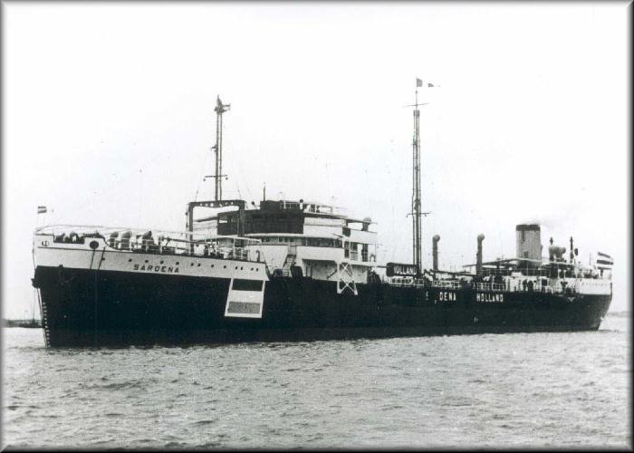
s.s. “Saroena”

Whilst on service in the Mediterranean the s.s. “Saroena” of the Nederlandsch-Indische Tankstoombootmaatschappij was struck by a torpedo at 1:30 am on the night of February 11th 1943 twenty-one miles off the coast of Ras Beirouth. The 6670 B.R.T. ship carried a cargo of crude oil for Haifa.

The torpedo exploded in the aft tank and started a violent fire at the stern. To escape death by fire everyone in the area got in one of the life boats whilst the ship was still moving.
The engineer on duty escaped the flames without being able to stop the engines. With the stern in flames the “Saroena” continued to move without anyone in the engine room, when Captain Happee got no reply from the engine room he realised that there was no living soul down there.

After that he instructed all hands on board to put their life vests on and proceed to the foredeck. Two gunners and three Chinese got hold of a Carley float stacked amidships and left the ship.

Burning oil sprayed with great force from the ruptures tank and was spreading across the water. To keep his ship free from the floating burning oil as much as possible Captain Happee steered a zigzag course. Fortunately the steering engine worked and there was sufficient steam pressure from the boilers to continue sailing and even blowing the safety signal on the ship’s horn. Still making 7 to 8 knots the captain navigated the “Saroena” towards the shore.

Trying to make radio contact with the port authorities in Beirouth was unsuccessful, all electric cabling from the engine room to the midship accommodation and bridge had burnt out.

One of the naval escorts that had come to the aid of the “Saroena” stayed a good distance away from the burning vessel and advised the crew to jump over board. Captain Happee, who saw an opportunity to save his ship, did not agree although the fire was spreading even further. Attempts to extinguish the fire with the ship’s own equipment were unsuccessful.

With his ship on fire Captain Happee sailed past the port of Beirouth and with his Aldis lamp asked for instructions where he could run the “Saroena” aground.
As per instructions in the answer he received he set course and ran the “Saroena” aground in the mud at a quarter to five in the morning with the engines still running.
In order to prevent the ship from settling to hard the starboard anchor with 25 fathom of chain was dropped.

By then it was high time to desert the ship because the ever increasing fire made the situation for those who were still on board more dangerous by the minute.
The burning oil kept spreading further on the water and since neither life boat nor float was available swimming was the only way to reach the shore.
One after the other the men jumped over board and the third mate, who happened to be a good swimmer, took the responsibility of taking the container with the ship’s documentation with him. All reached the shore safely, the container got lost.

Straight away Captain Happee made contact with the port authorities and went back on a vessel with them to the burning “Saroena”.
By ten o’clock in the morning they managed to finally control the fire from the port authority vessel but then they were faced with the problem of how to refloat the badly damaged wreck.
After a preliminary inspection two navy escorts started to pull to free the ship, however, the “Saroena” had settled too hard in the mud that towing had no effect. To lighten the ship a barge was brought alongside from where the remaining crude oil was pumped out of the tanks resulting in re-floating the “Saroena”

Inspection showed that the ship was badly damaged and that both boilers were nearly dry. The engine had continued running for approximately seven hours without feeding the boilers.

Because of brave conduct by Captain Happee and his crew the “Saroena” was not a total loss.

