The Coptic
Multi-Media Database Project

Instigated and designed by archaeologist Howard Middleton-Jones, the continuing development of the project is being carried out in collaboration with Howard and the St Mark Foundation for Coptic History Studies

http://www.coptic-history.org/

For further details and to assist in the project, please contact:

Howard Middleton-Jones

howardmj@yahoo.com
h.middleton-jones@swan.ac.uk

http://www.ambilacuk.com/coptic/cmdbase.html

Thanks to Dr. Gawdat Gabra and the St Mark Foundation for Coptic History Studies

Advantages of the Coptic Database Project

- To pool resources and data into one major location
- To enable rapid search and find to generate reports
- To enable map generation and overlays of Monastic site distribution
- To provide accurate geographical locations of sites
- As a major source of references and bibliographies
- To access multi-media film, photographs and satellite imaging
- To provide vital data and information from excavation reports
- As a tool for the retrieval of reports to aid preservation and conservation
- To enhance our understanding of the Coptic culture and promote the Coptic heritage

The Coptic
Multi-Media Database Project

Towards the documentation and recording of data for all Monastic sites in Egypt

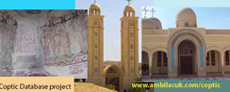

http://www.ambilacuk.com/coptic/cmdbase.html

Introduction

While in recent years Coptic studies witnessed a remarkable progress especially in monastic art, actual monastic site documentation appears to have been sadly lacking. It is with this consideration in mind the idea of the design and development of the Coptic Multi-Media Database was born.

There are a considerable number of Coptic monasteries distributed throughout mainly desert areas in Egypt, some in ruinous condition, and indeed a large number possibly never documented at all. However, many of these monasteries contain extremely rare and important architectural and archaeological elements, such as ancient wall paintings, icons and unique carvings.

It is extremely important that these sites be systematically documented and recorded, and while a few have been excavated over the years, a system whereby the resulting pooled information may be accessed alongside interactive visual multi media documentation, has, until now, not been available.

To this end, it was proposed in 2007 to instigate the design and development of such a database, which was based on the design of the Akhmim project (1997)1

By developing such a database, which includes; full text descriptions, photographs and video, satellite imagery, exact GPS coordinates, bibliographies and complete descriptions of the art and architectural elements, the end result would be a unique and important tool for the retrieval (and reconstruction) of archaeological records of Monastic sites.

With the cooperation of Coptic researchers and associated organisations, the end result would not only greatly improve and enhance our understanding of the Coptic heritage, but also provide vital and essential data towards the preservation and restoration of important Monastic sites, thus maintaining a credible resource for the continuation of Coptic culture

Most aspects of Coptic culture are represented in the monasteries of Egypt, and therefore are a major source for the study of Coptic architecture, sculpture and painting

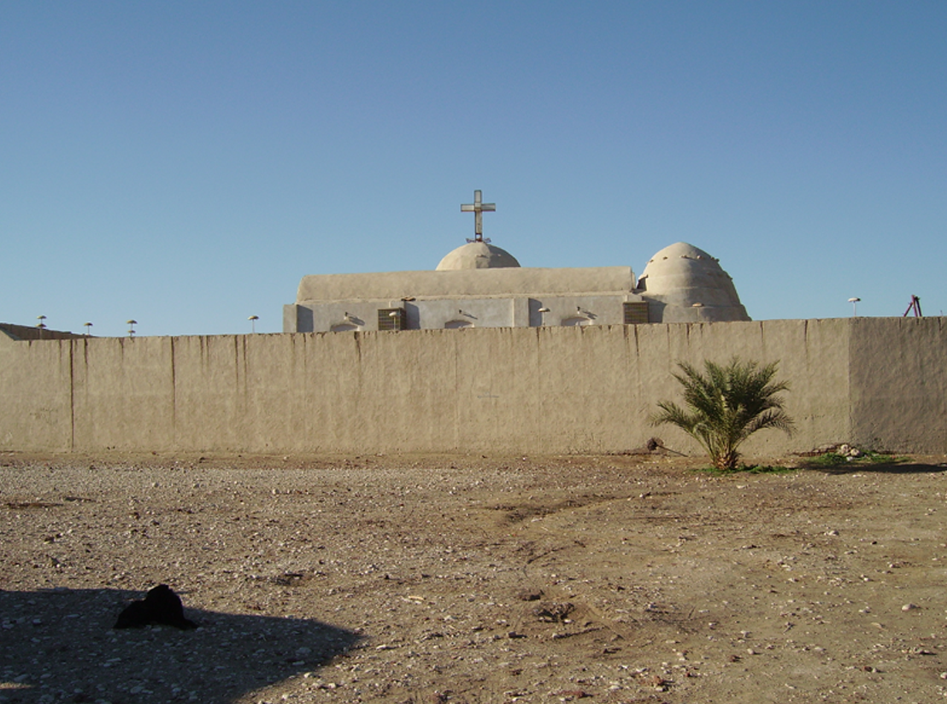
It is thus imperative that vital documentation and recording be carried out to preserve the legacy of this important period.
The Coptic database project will serve as a vital tool in enhancing our understanding of this exceptional era, and assist towards a programme of preservation and conservation

1 Howard Middleton-Jones 1997 The Akhmim Project. The Analytical Catalogue of Material from the Late Period Cemeteries of Akhmim in Upper Egypt.

